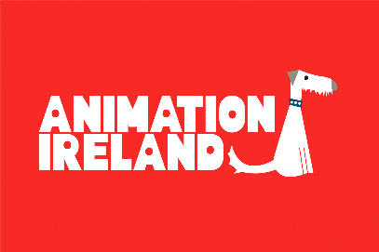

Following the first iteration of this initiative in 2021, Screen Ireland / Fís Éireann in collaboration with Animation Ireland and with the support of Immersive Technologies Skillnet & Eirmersive has provided a second allocation of €350,000 in funding that will be invested in new innovative, high concept development and immersive storytelling opportunities within the Animation and Immersive Storytelling sector. Animation Ireland is committed in their ambition to highlight Ireland as a centre of excellence in Animation and investing in a diverse and broad cross pollination of skills, talent, genres and stories that are fuelled by powerful creative artistry and world building.

Please see Call for Applications for further details and guidance.
CONTACT NAME(S):
ORGANISATION NAME & ADDRESS:
TELEPHONE
EMAIL ADDRESS
CONTACT NO.
DATE | / / 2022

1.
Company Profile & History
- A short biography of company and previous work
- Team profiles or CVs of project team
(Two Pages Max.)

2.
Concept
- Project title
- Detailed outline of the story idea and concept development work to be undertaken
- Timeline for activity
- Intended delivery method / platform
- Highlight innovative aspects of the concept as it relates to your current work profile
Please attach as appendices:
- Copy of the script or draft script (where applicable)
- Budget and Finance needs

3.
Market & Audience
- Research and data in relation to how your concept will achieve further opportunity within the market and reach an audience
- Festival or distribution strategy.
- What are the current trends and needs at present? What is the definition for success?
(One Page Max.)

4.
Ownership and Further Notes
Market and Stakeholder Needs
Highlight any specific detail in relation to ownership and stakeholder involvement in concept
Further reference notes or comments in relation to the broader aspects of the idea and how they meet the objectives of the callout
(One Page Max.)

5.
Built for the Future
incl. Diversity, Inclusion and broader Sustainability Opportunities
Rationale in how the investment will support and give increased profile to Animation Ireland’s Diversity, Inclusion and Sustainability goals
(One Page Max.)

Data Protection
Animation Ireland is required to collect data, including certain personal data, to process your application. Animation Ireland is committed to protecting and respecting your privacy, and will therefore ensure that all information that you provide to us is safeguarded. Animation Ireland only requests data that is required for a legitimate purpose and for which we have a valid legal basis to process which is to facilitate the processing of your application. Animation Ireland requests that you do NOT send personal data on yourself or third parties, associated with your application, that has not been requested, or that you have not acquired permission to use. The data may be used for statistical purposes. The data collected may be stored, processed and passed in confidence to or shared with third parties, individuals or organisations, who are helping us assess applications or monitor funding. We require all such third parties to enter into a data processing agreement with us, which complies with our obligations under the new EU General Data Protection Regulation (GDPR). This processing agreement requires such third parties to have appropriate data security systems in place and only to use your personal data on our instructions and in accordance with data protection law.

All personal data information will be treated in accordance with the GDPR and associated data protection laws. You have rights under the GDPR including the right to ask for a copy of your personal data information held by Animation Ireland and the right to require Animation Ireland to correct any inaccuracies in your personal data.

I consent to the data provided being processed for the purposes outlined above. ☐

Please return to:

applications@animationireland.com

by 13.00 Wednesday 16th March 2022.

